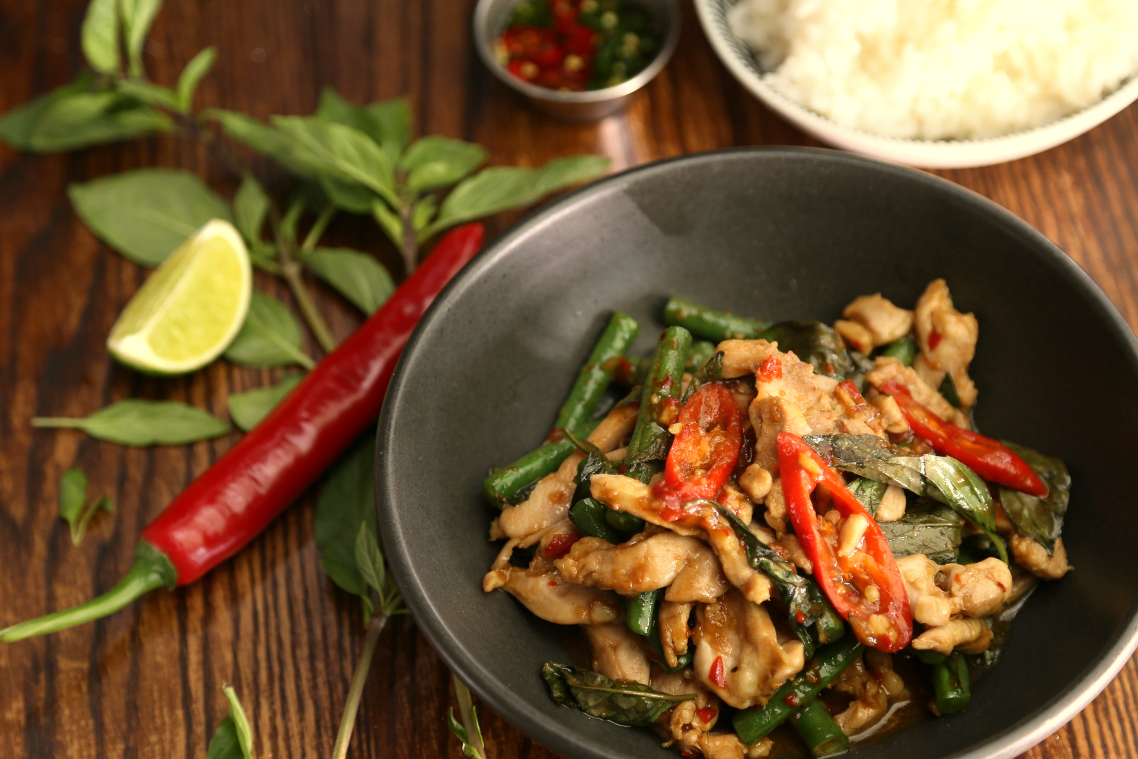

**Evergreen**

**Thai Restaurant**

**L.L.B.O**

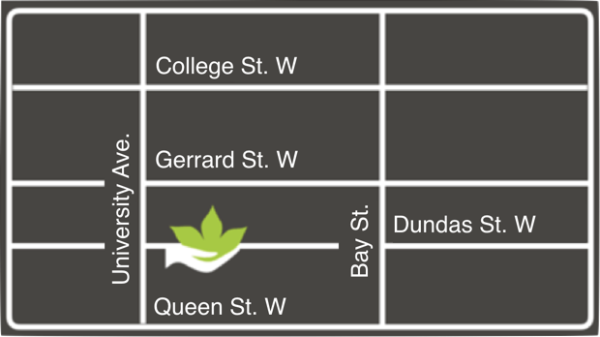

**Business Hours**

Mon-Fri: 11am-11pm

Sat: 11am-10pm

Sun: 3pm-10pm

**Order Takeout** @ 416.581.8668 or evergreen.com

**Address**

175 Dundas St .West, Toronto, ON, M5G 1C7



**Evergreen**

**Thai Restaurant**

**L.L.B.O**